|  |  |
| --- | --- |
|  | Assignment 1 |
|  |  |
|  | Rushabh Barbhaya  SYS 660 – Decision making via risk analysis  2/4/19 |

Assignment 1

# Question 1 What. are your fundamental objectives in the context of renting an apartment while attending college? What are your means objectives? Create a fundamental-objectives hierarchy and a means-objectives network.

# Solution 1:

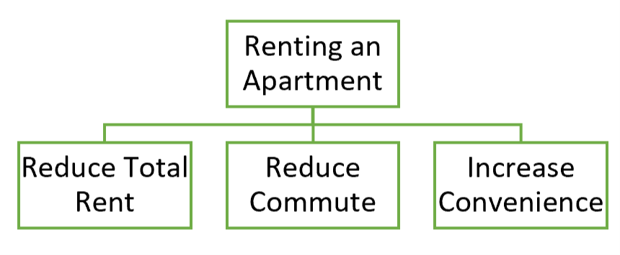

Figure 1 - Fundamental-objectives hierarchy diagram for renting an apartment

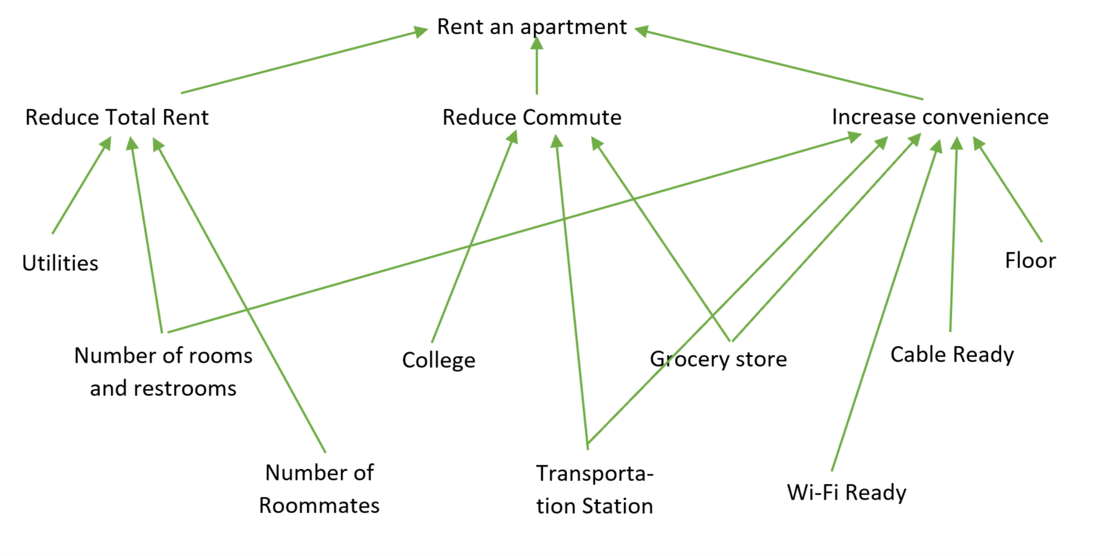

Figure 2 - Means-objectives network diagram for renting an apartment

The fundamental objectives for me are reducing the overall rent, reduce commute time and increase overall convenience.

To reduce the overall rent, the number of rooms and restrooms are an important controlling factor. Along with that the number of roommates for the said room can also divide the rent among the tenants. If the apartment comes with utilities the rent helps other expenses. Utilities include; electricity, gas, water, sewage, heating and laundry.

For reducing commute time, how close the apartment is to the college plays a vital role. Closest transportation station (examples include- bus stop, train stop, etc.). The commute to local grocery stop is also important as I don’t like to spend to much time on grocery shopping and other miscellaneous shopping stops.

For increasing overall convenience, the apartment should include Wi-Fi or should be Wi-Fi ready along with cable. The floor of the said apartment shouldn’t be too high or too low. Should have an “emergency” grocery store nearby and should have any mode of transportation, which can be used, a short walk away.

Question 2 Before making an unsecured loan to an individual a bank orders a report on the applicant's credit history. To justify making the loan, the bank must find the applicant's credit record to be satisfactory. Describe the bank's decision. What are the bank's objectives? What risk does the bank face? What role does the credit report play? Draw an influence diagram of this situation. (Hint: Your influence diagram should include chance nodes for a credit report and for eventual default.) Finally, be sure to specify everything (decisions, chance events, objectives) in your model clearly enough to pass the clarity test.

Solution 2:

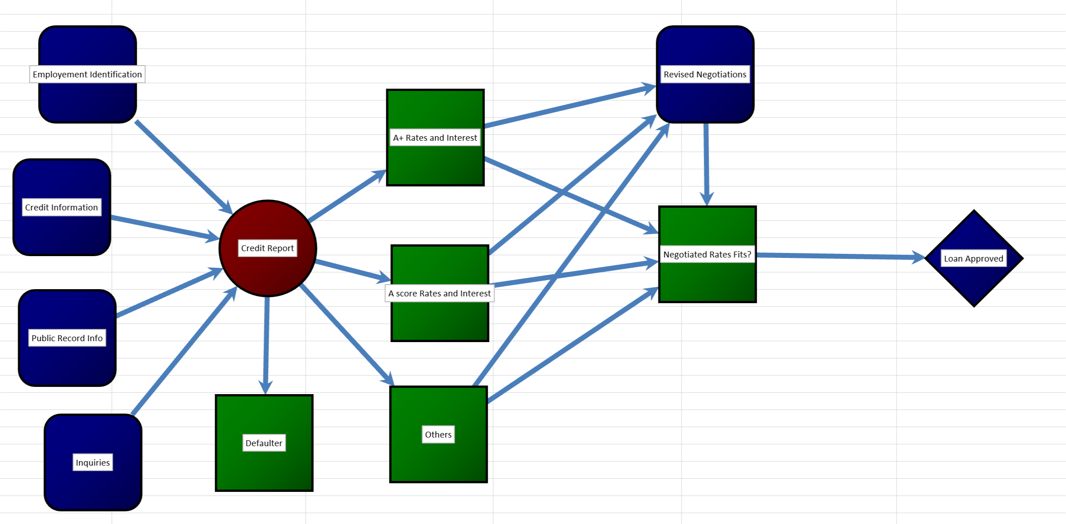

Figure 3 - Influence Diagram for Bank Loan

For a bank to issue a loan, they check the credit report for the applicant. A credit report is consisting of a lot of information. It includes the identification information, credit information, public records for that individual, inquiries on that person and various other parameters. It does not include race, religion, health, driving record, criminal record, political preference, or income. [1]

Since, we are talking about an unsecured loan, we don’t have to worry about any collaterals. So, when a credit report is out, depending on the score of an individual it categorizes them in A+, A, … Depending on those categories the bank suggests an interest rate and maximum amount of loan which can be issued. Or if the individual is a defaulter, they reject the application. There is a chance that an individual may not get the amount of loan or the interest charged.

There is always a breathing room when rates are discussed with the bank and an individual can negotiate on it. If they system allows it new rates can be set. If the rates are not allowable by the system, it’s on the individual if they want to continue with the given rates or drop the application.

The bank tries and suggests a best rate and payment method which won’t make a huge “dent” on the applicant’s lifestyle. Suggestions are made on how long the applicant must make payments and how much they must pay for each term.

The is at the possibility of loosing money if the person defaults on the payments or is behind on the payments. The loan being unsecured, there will be no possible way to recover the money. To counter that, banks usually keep on auto charging on the account with prior notification, of course, but banks can still be on the loosing end for this method.

The sole objective of the bank is to make sure that the applicant is repaying the loan on time. That’s the way the bank makes money.

# Question 3 Build an influence diagram to describe the decision to rent an apartment you considered in question 1. Your objectives hierarchy and means network should inform the influence diagram.

Solution 3:

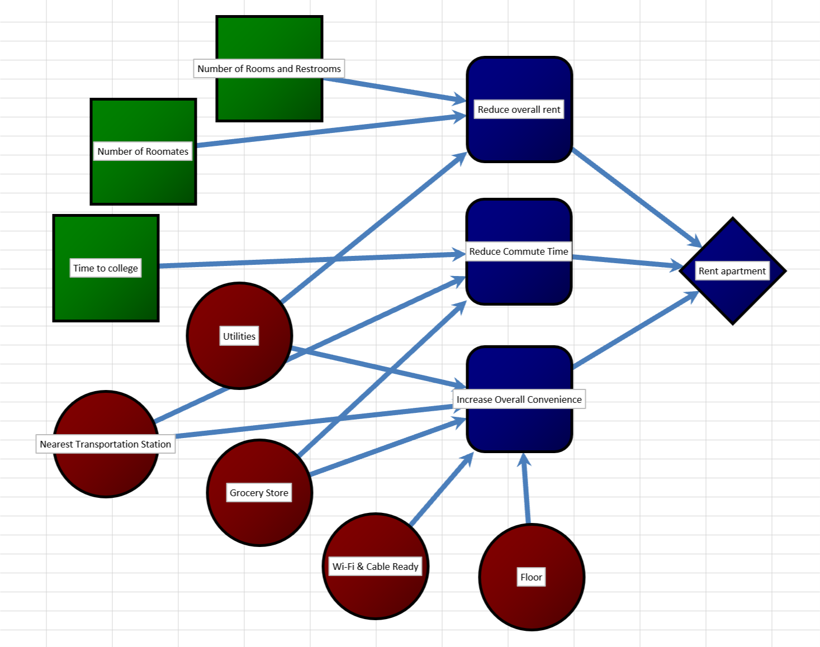

Figure 4 - Influence diagram for renting an apartment

When selecting an apartment, I have a choice for choosing the number of roommates and the number of restrooms I require. Also, I have an option to choose the number of roommates. The combination of these decisions is dependent on me and are the main sources to reduce the rent for the apartment. Utilities are dependent on the landlord, some apartments come with utilities included in the rent, others come with some utilities included and others come with none of the utilities included in the rent. They can also drive the rent of the apartment in either direction.

Second important factor for me is the overall commute. It is important that the overall commute time to the places of my interest are as low as possible. The most important place of interest being college, I would want to reduce the commute time to college to as low as possible. I can leave others to chance. For example, the commute to local grocery store, transportation stop, etc. I can walk a little for them. But I would wish the commute to college be a deciding factor (example: Commute to college shouldn’t be more than 30 minutes.)

The third important factor is overall convenience. I can leave all of these to chance. I can make a compromise on these objectives but not to the others. This includes the floor for the apartment. I wouldn’t want the apartment too high or too low. I wouldn’t want my local grocery store to be more then 10 min walk. I would like my apartment to be Wi-Fi and cable ready, but it wouldn’t be the case for the apartment I like.

These are all the parameters over which I would choose my apartment.

# Question 4 Download Daily Skimm on your mobile phone or computer using this link: [theskimm.com/?r=634c9b5e (Links to an external site.)Links to an external site.](https://link.theskimm.com/click/15842534.3226019/aHR0cHM6Ly93d3cudGhlc2tpbW0uY29tP2VtYWlsPXllZ2Rvb25laEBnbWFpbC5jb20mcj02MzRjOWI1ZSZmcm9tX2RzPXRydWUmaXNzdWUtZGF0ZT0yMDE5LTAxLTI5/5babd9ae3f92a46ecb60d563C297f8318) Identify a decision related to a current event that interests you from The Skimm. Include the link to the news so that I know what you have selected/identified. What are the fundamental objectives related to the decision you have identified? What are the mean objectives that you can identify? Create an influence diagram for the decision.

Solution 4:

***Disclaimer: Since I signed up for skim today. I’m dependent on the archive of February 5, 2019.***

**Article:** Slack confidentially files to go public

**Publication:** [CNN Business](https://www.cnn.com/business)

**Author:** [Sara Ashley O’Brien](https://www.cnn.com/profiles/sara-obrien)

**Date:** Updated 4:52 PM ET, Mon February 4, 2019

**Skimm Archive:** [Archive Link](https://theskimm.com/archive/2019-02-05)

**Skimm Article:** [Article Link](https://www.theskimm.com/2019/2/4/skimm-for-february-5th-6?jumpto=jumpto-7762321&utm_source=twitter&utm_medium=dsshare)

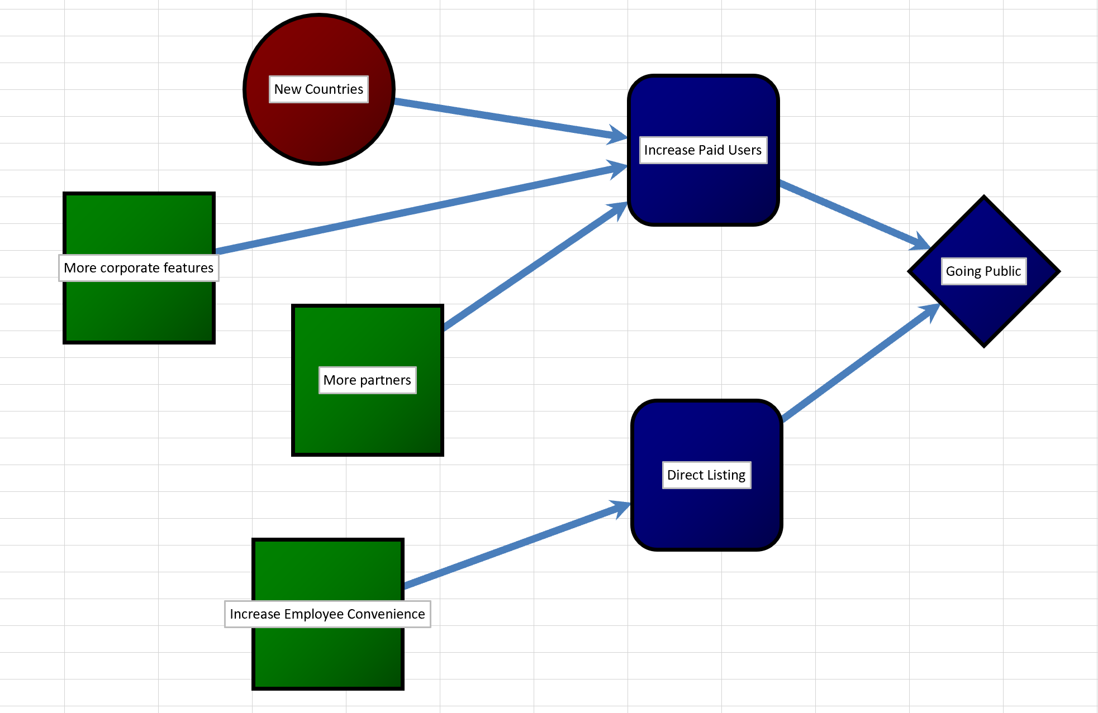

Figure 5 - Influence diagram for Slack Going Public

The slack team has confidentially filed its IPOs and here is the breakdown of its decision. To the best of my knowledge, Slack decided to go public for two fundamental reasons. To increase its revenue and for easing employees to buy and sell company stocks.

One of the fundamental objectives is to increase revenue. Slacks’ source of income is its paid users. Slack already has a large pool of paid users in Japan. They would like to increase its pool by going to new countries with its business model. Other key decisions are adding more corporate features and add more business partners. Through these decisions they can generate revenue.

Other fundamental objective was to directly list its IPOs instead of waiting for a long time for employees and stock holders to buy and sell on day 1 of trading. [2]

# References

|  |  |
| --- | --- |
| [1] | F. B. H. Mortgage, "Loan Process," Farmers Bank, January 2019. [Online]. Available: http://www.farmersbankhomemortgage.com/loan-process/#8. |
| [2] | Sara Ashley O'Brien, "Slack confidentially files to go public," CNN Business, 4 February 2019. [Online]. Available: https://www.cnn.com/2019/02/04/tech/slack-ipo-filing/index.html. |